С.Д. КОЛОКОЛЬЧИКОВ, Ю.В. СЕНИЧЕВ

Институт ядерных исследований РАН, Москва, Россия
Московский Физико-Технический Институт, Долгопрудный, Россия

МАГНИТООПТИЧЕСКАЯ СТРУКТУРА КОЛЛАЙДЕРА NICA С ВЫСОКОЙ КРИТИЧЕСКОЙ ЭНЕРГИЕЙ.

Исследованы способы повышения критической энергии для протонной опции коллайдера NICA. Применен метод суперпериодической модуляции градиентов квадруполей. Осуществлен выбор секступолей для подавления натуральной хроматичности и компенсации секступольной компоненты. Приведены параметры Твисса для предложенных структур, а также исследованы динамические апертуры и рабочие точки.

S.D. KOLOKOLCHIKOV, Y.V. SENICHEV

Institute for nuclear research of RAS, Moscow, Russia
Moscow Institute of Physics and Technology, Dolgoprudny, Russia

MAGNETO-OPTICAL STRUCTURE OF THE NICA COLLIDER WITH HIGH CRITICAL ENERGY.

Methods of increasing the critical energy for the proton option of the NICA collider are investigated. The method of superperiodic modulation of quadrupole gradients is applied. The selection of sextupoles is carried out to suppress the natural chromaticity and compensate for the sextupole component. The Twiss parameters for the proposed structures are given, as well as the dynamic apertures and working points are investigated.

Протонная опция коллайдера NICA.

First of all the structure of the NICA collider was designed to work in two modes: for experiments with heavy ions $^{79}{Au}_{197}$ and for experiments with polarized protons/deuterons p, d. At the maximum collision energy in the heavy ion collision experiment of 4.5 GeV/nucleon, the critical energy of the magneto-optical structure of the collider is $E_{tr}^{Au-Au}=5,7 ГэВ$ ( $γ_{tr}^{Au-Au}=7,1 ).$ In this case, there are no problems with the transition through the critical energy that was originally taken into account when designing. This value of the critical energy was achieved by choosing the frequency of betatron oscillations in the horizontal plane $ν_{x}≈γ_{tr}^{Au}>γ_{max}^{Au}≈7.1$, which is subject to the regularity of the structure of the arches consisting of identical cells of the FODO, must be greater than the maximum value of the Lorentz factor in the entire energy range. This regularity condition of the structure is simultaneously necessary to minimize the modulation of the beam envelope, coinciding with the condition of minimizing the effect of intra-beam scattering in the heavy-ion option with a large particle charge. Small perturbations at the edges of the arch due to the dispersion suppressors by the missing magnet method do not play a fundamental role in all of the above.
Crossing through the critical energy g, a longitudinal instability develops. Threshold current of its instability development $I_{th}\sim η$ proportional to the slip-factor η, which is equal to zero when $γ=γ_{tr}=7,1$. At transition, the rate of acceleration of protons using the induction acceleration of the RF1 station is $dγ/dt=0.2c^{-1}$. This rate is too small to avoid the development of instability when the relativistic factor approaches to $γ_{tr}$.
The magnetic rigidity of the rotary magnets is constant $R_{arc}⋅B_{bend}=\frac{A⋅mcγβ}{eZ}≈45$. Thus, the maximum possible energy in the proton acceleration experiment is determined $E_{max}^{p}=12,4 ГэВ (γ^{p}=14,3)$, therefore, the gamma-critical must be at the level of $γ_{tr}^{p}\sim 15-16$, which is obviously higher than the critical energy for an ionic regular structure $E_{tr}^{Au-Au}=5,7 ГэВ$ ( $γ_{tr}^{Au-Au}=7,1$). In order to exclude the crossing through the critical energy during proton acceleration, a new optical ring structure must be implemented for the proton mode instead of the optical structure of the ion mode. In this optical structure, the critical energy must be higher than the maximum proton energy when the collider is operating for the experiment.
For a proton beam with an intensity of 2×10¹³ the time of intra-beam heating increases by about 30 times compared to beams of gold ions with an intensity of 6,6×10¹⁰. Therefore, the critical energy can rise due to the variation of the dispersion without fear of the influence of intra-beam scattering. Due to the resonant modulation of the dispersion function, the diffusion coefficient for intra-beam scattering increases by 2-3 times, this is not critical both when protons are cooled during accumulation, and when they are grouped at the energy of the experiment.

Введение суперпериодической модуляции.

The momentum compaction factor is defined as
$$α=\frac{1}{γ}=\frac{1}{C}\int_{0}^{C}{\frac{D\left(s\right)}{ρ\left(s\right)}ds},(1)$$

where $C$– the length of a closed equilibrium orbit, $D(s)$ – horizontal dispersion function, $ρ(s)$ – radius of curvature of the equilibrium orbit.
Equation for the dispersion function with biperiodic variable focus
$\frac{d^{2}D}{ds^{2}}+\left[K(s)+εk(s)\right]D=\frac{1}{ρ(s)}$, (2)

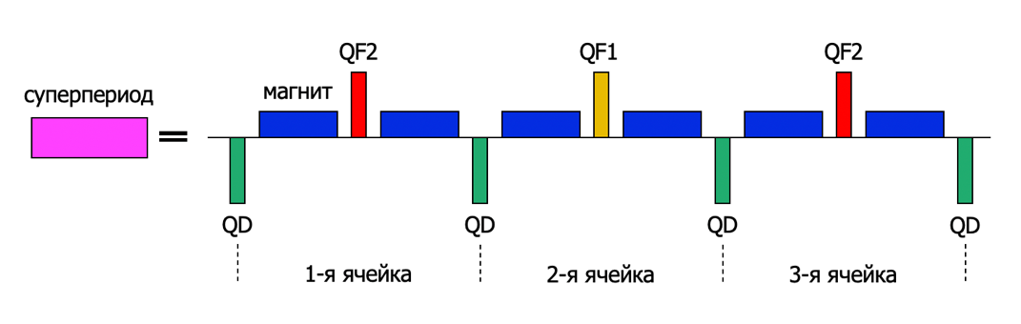
where $K\left(s\right)=\frac{e}{p}G\left(s\right)$, $εk\left(s\right)=\frac{e}{p}ΔG\left(s\right)$, $G\left(s\right)$ – gradient of magneto-optical lenses, $ΔG\left(s\right)$ – superperiodic gradient modulation. A superperiod is defined as a combination of several FODO cells as shown in Figure 1. Thus, in the general case, the coefficient of expansion of the orbit depends on the functions: the curvature of the orbit $ρ(s)$, gradient and modulation of quadrupole lenses respectively $G\left(s\right)$, $ΔG\left(s\right)$. In the NICA structure, the regular arrangement of dipole magnets eliminates the possibility of modulating the curvature of the orbit. Therefore, we use only the modulation of the strength of the quadrupole lenses over the length of the superperiod. Function $K\left(s\right)$ has a periodicity of one period of the focusing cell, $k(s)$ has a superperiod periodicity. For one superperiod, the momentum compaction factor is determined by the formula (3), the conclusion of this formula is made in [1]:
Рисунок 1 Введение суперпериода, состоящего из 3-х ФОДО ячеек

$$α_{s}=\frac{1}{{ν_{x,арк}}^{2}}\left\{1+\frac{1}{4}{\left(\frac{{\overline{R}}_{arc}}{ν_{x,арк}}\right)}^{4}\sum_{k=-∞}^{∞}{\frac{{g_{k}}^{2}}{(1-kS/ν_{x,арк})[1-(1-kS/ν_{x,арк})^{2}]^{2}}}...\right\}, (3)$$

where ${\overline{R}}_{arc}$ – the average value of the curvature, $ν_{x,арк}$ – the number of horizontal betatron oscillations on the length of the arc, S – number of superperiods per arc length, $g_{k}$ –$k$-th harmonic of the gradient modulation in the Fourier series expansion of the function $εk\left(s\right)=\sum_{k=0}^{∞}{g_{k}}cos(kϕ)$. Due to the mirror symmetry, the decomposition is performed in cosines. In the absence of superperiodic modulation $g_{k}=0, ∀k$, formula (3) takes the form $α_{s}=\frac{1}{{ν_{x,арк}}^{2}}$, which corresponds to the case of a regular structure. To raise the critical energy, it is necessary to reduce $α_{s}=1/γ_{кр}^{арк}$, this means that the expression under the sum sign must be negative, this is realizable under the condition $\frac{kS}{ν_{x,арк}}>1$. First harmonic $k=1$ has a dominant influence and for 12 FODO cells, the condition is implemented $S=4$, $ν_{x,арк}=3$, where 3 FODO cells are combined into one superperiod. Thus, due to the tune of betatron oscillations of a multiple of 2π, the arc has the properties of a first-order achromate.

Previously, all formulas were given for the arc, and not for the entire ring of the collider. The insertion of straight sections reduces the degree of modulation of the dispersion function. The average value of the dispersion decreases with a longer orbit length, this means that the momentum compaction factor decreases for the entire accelerator, and the resulting value of the critical energy $γ_{tr}^{total}$ increases and is determined by the expression:
$$γ_{tr}^{total}=γ_{tr}^{arc}\sqrt{\frac{S⋅L_{s}+L_{str}}{S⋅L_{s}}} (5).$$

Рассмотрение способов поднятия критической энергии методом суперпериодической модуляции.

To increase the critical energy of the NICA accelerator ring, the possibility of changing the dispersion function by modulating the gradients of the quadrupoles on the rotating arcs of the ring is considered. To do this, consider a superperiod consisting of 3 FODO cells, where the central focusing quadrupole differs from the two edge ones by a larger gradient value.
An important requirement in the design of a magneto-optical structure is to ensure zero dispersion in straight sections to ensure the movement of particles along the equilibrium orbit in these sections. This requirement is easily implemented in the case of creating regular rotating arcs composed of identical superperiods. In this case, by providing a zero dispersion value $D=0$ (as well as the derivative of the dispersion $D'=0$) at the entrance to the arc, due to the regularity, the output of the arc will also have zero values of the dispersion and its derivative, and therefore on the entire straight section. However, the peculiarity of the given structure of the NICA collider, the presence of missing magnets on the two extreme cells does not make it possible to create a completely regular arc of 4 identical superperiods. Thus, it is necessary to ensure the suppression of dispersion at the edges of the arch. Two possible cases of dispersion suppression are considered:
- Dispersion suppression with edge superperiods.
To be precise, the dispersion suppression is carried out by using two edge FODO cells located symmetrically on both sides. Figure 2 and 3 above (Edge Suppressor – ES) show a schematic diagram of this magneto-optical structure. As can be seen, the two edge FODO cells differ differ in the presence of a missing-magnet and in these cells, the QFE1 and QFE2 quadrupoles also have different gradients from the main arс quadrupoles and are selected to suppress the dispersion.
- Dispersion Suppression by the arc, by selecting the gradients of the quadrupoles of the two families.
Figure 2 and 3 below (Arc Suppressor – AS) shows a schematic diagram of this magneto-optical structure. This case differs from the first, all the quadrupoles of the arch belong to the first or second family, and the suppression of dispersion is also provided by only 2 families.
The defocusing quadrupoles in both the first and second cases belong to only one QD family.
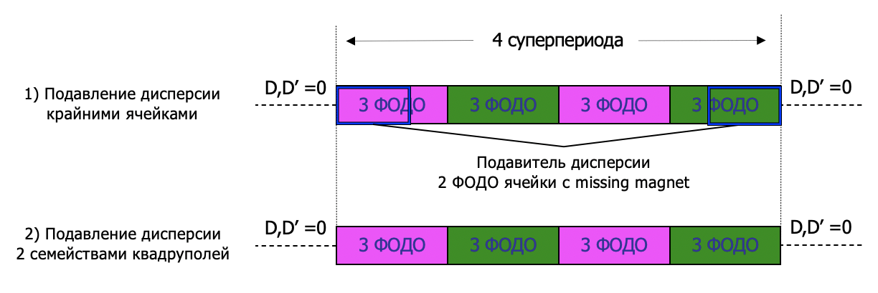
Figure 3 The scheme of arrangement of quadrupoles on the arc of the accelerating ring, providing a variation of the critical energy and performing the function of dispersion suppression in straight sections. The case with the possibility of dispersion suppression by edge superperiods (Edge suppressor) is shown above. Below, the dispersion is suppressed only by matching the gradients of two families of quadrupoles (Arc suppressor).
Figure 2 Schematic diagram of two possible dispersion suppression options for the proton option of the NICA collider.
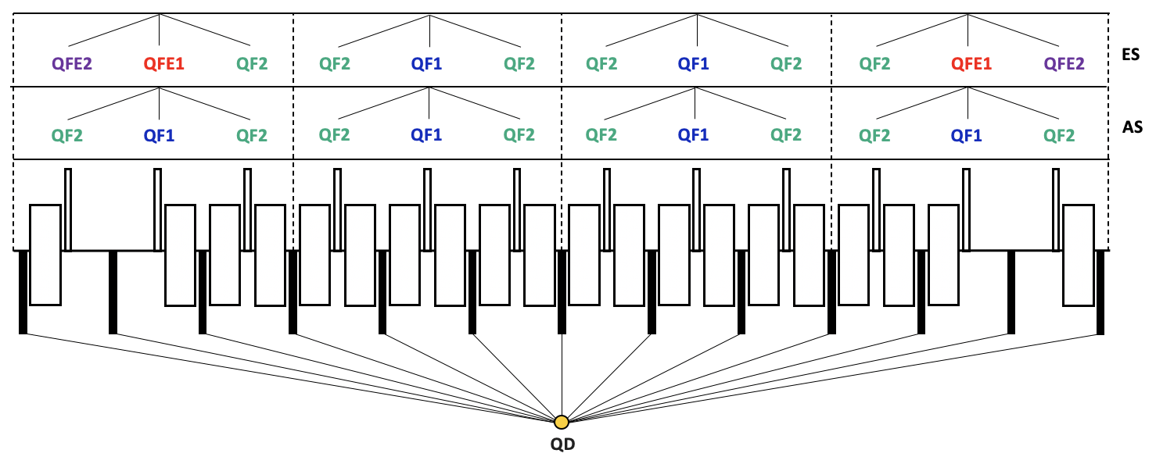
  - Подавление дисперсии крайними ячейками арки
    - Выбор градиентов квадруполей

The choice of the value of the gradients of the arc quadrupoles is determined by two factors:
- Obtaining the required value of the critical energy on the entire ring of the collider, which corresponds to $γ_{tr}\sim 15-16$;
- Provide the number of betatron oscillations on the arc $ν_{arc}=3$ in both planes, thereby satisfying the resonant condition for the number of superperiods $S=4$.

Квадруполи | Градиент, T/m
QF1 | 28,26481
QF2 | 20,9276
QD | 22,62231
QFE1 | 30,9342
QFE2 | 19,58429
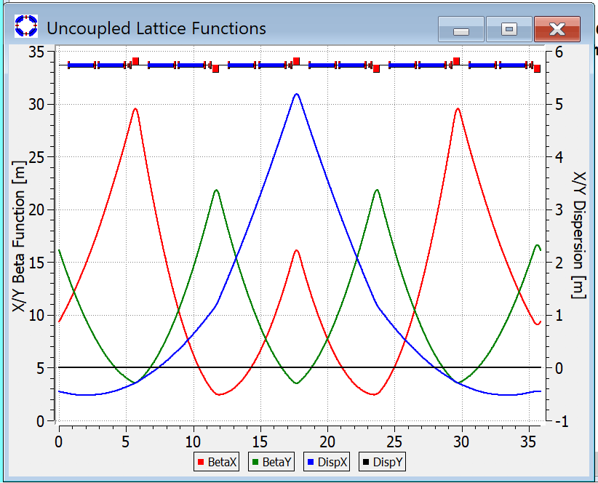
Based on these conditions, we modulate the superperiod with a phase shift on the superperiod $ν_{S}=0,75$ in both planes (Figure 4).
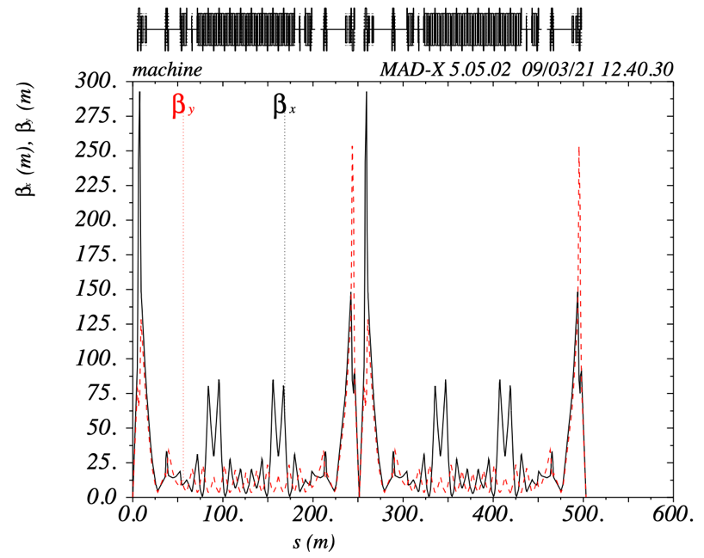
Рисунок 4 Модулированный суперпериод $ν_{S}=0,75$
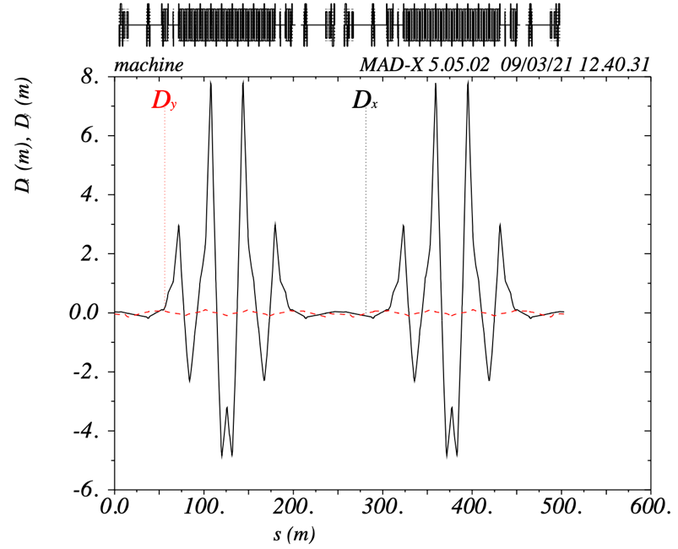
Рисунок 5 Подавление дисперсии крайними ячейками арки
Слева – бета-функции; Справа – дисперсионные функции.
The collider also consists of 2 arcs and 2 straight sections connecting both arcs. In the middle of the straight sections there are collision points, where it is necessary to provide a small value of the beta function to achieve the required luminosity. Figure 6 shows the Twiss parameters of the entire collider ring without introducing the edge quadrupoles QFE1 and QFE2, it is clearly seen that the dispersion is not suppressed in the straight sections. The edge superperiod has a missing magnet in 2 cells, thus making the collider arcs not regular and there is a need to suppress the dispersion in straight sections using the introduction of 2 additional families of QFE1 and QFE2 quadrupoles on the edge of the arc, the beta-function and dispersion function of all entire ring are shown on Figure 5.
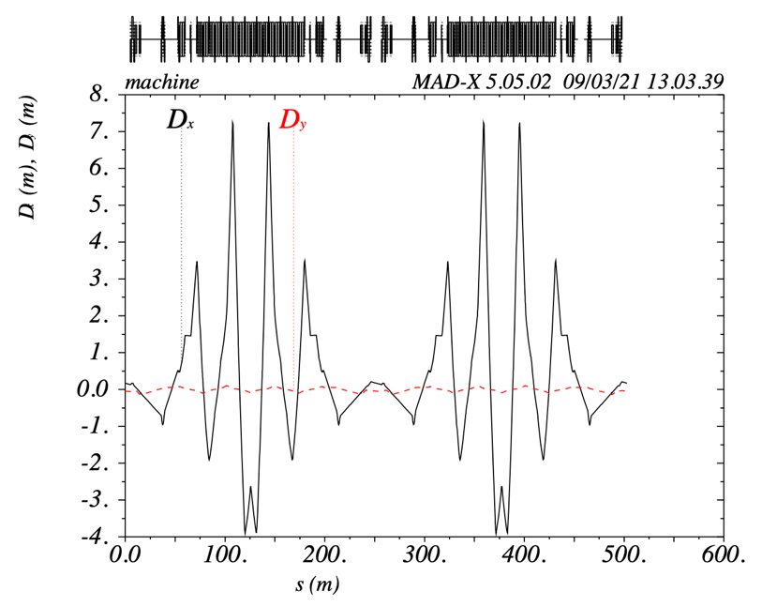
As a result, the critical energy value is chosen in such a way that $γ_{tr}=15,6$, and tune shift over the circle: $ν_{x arc}=3,01, ν_{y arc}=3,01$.

Рисунок 6 Дисперсионная функция без введения подавителей дисперсии на 2-х крайних ячейках

    - Расстановка секступолей

The arrangement of the sextupoles also requires that several parameters are taken into account:
- First, it is necessary to suppress chromaticity on the entire collider ring;
- Secondly, to achieve a large value of the dynamic aperture, it is necessary to achieve mutual compensation of the sextupoles and make an achromat of 2 orders..

To accomplish the first condition, it is necessary to suppress the natural chromaticity, caused by linear elements-quadrupoles and dipoles. To do this, you need to set the sextupoles in the region of non-zero dispersion – on the arches near the quadrupoles.
Since the tune shift is on the arc $ν_{x arc}=3,01, ν_{y arc}=3,01$. Thus, at each superperiod, a tune shift occurs $0,75π$, including the edge ones. In the described case there is peaks of $β$-function on arc at quadrupoles QF2. Thus, the phase difference between the QF2 quadrupoles of the first and third (second and fourth superperiod) is not a multiple of $π/2$. Simultaneously, the number of betatron oscillations between the central quadrupoles (QF1 or QFE1) of 1 and 3 or 2 and 4 superperiods $ν_{1-3}=ν_{2-4}=1,5$. Thus, by placing the sextupoles of the same family next to the central quadrupoles, it will be possible to ensure mutual suppression of the sextupoles. Figure 6 shows a schematic diagram of the arrangement of sextupoles.
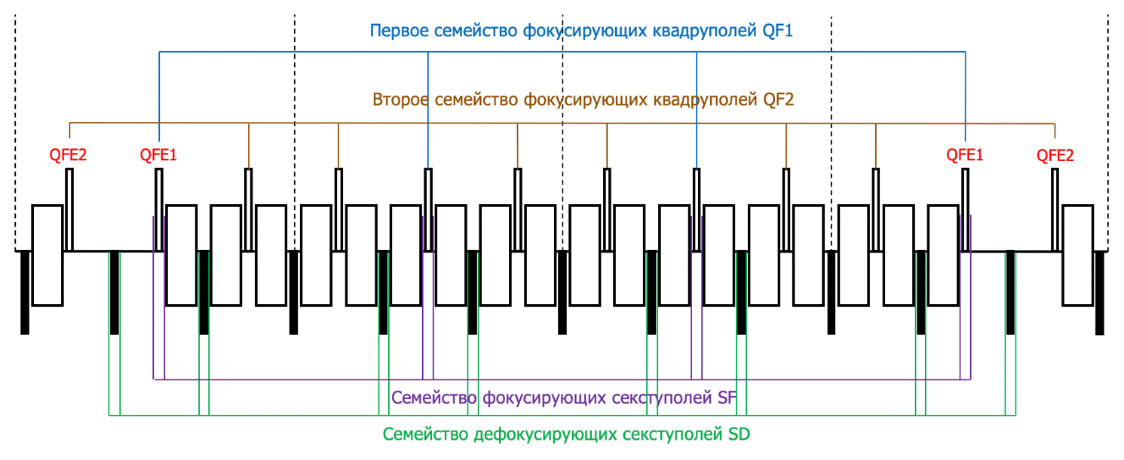
Рисунок 7 Принципиальная схема расстановке секступолей в случае подавления дисперсии крайними суперпериодами
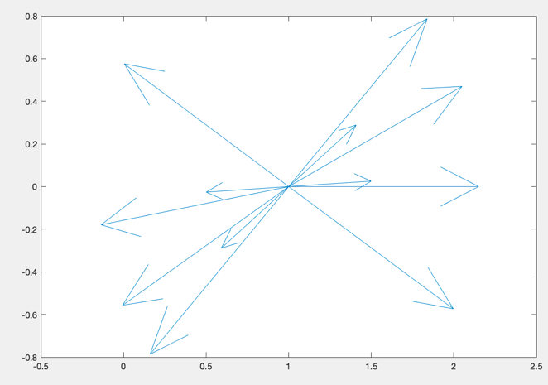
In this case, you need to make sure that the sextupoles are compensated with each other. In Figure 3, the corresponding gradients are represented as vectors, meanwhile, the rotation of the vector reflects the phase transition between the corresponding sextupoles and is equal to the number of betatron oscillations multiplied by $2π$ (the first sextuple of the arch was taken as a reference point). It can be seen that for each vector there is a vector that is directed in the opposite direction and compensates for it.
Рисунок 8 Векторы секступольных градиентов повернутые друг относительно друга с учетом фазы
    - Динамическая апертура и рабочая точка

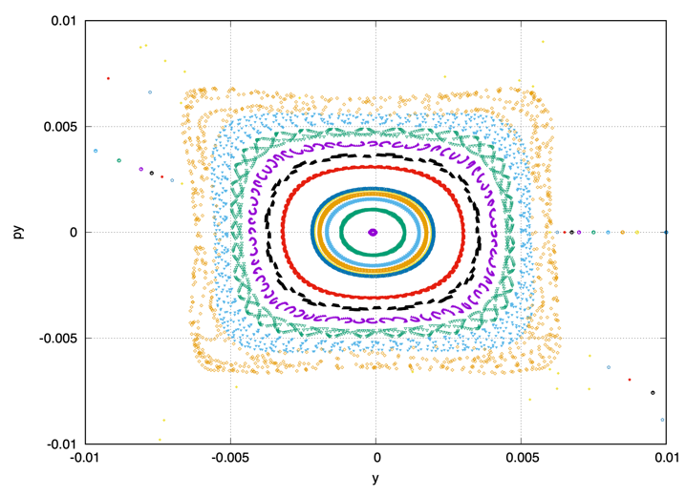
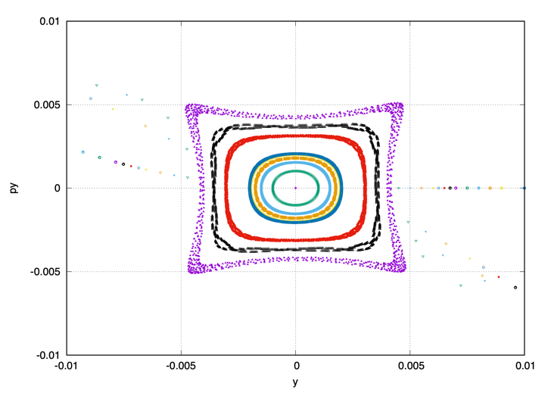
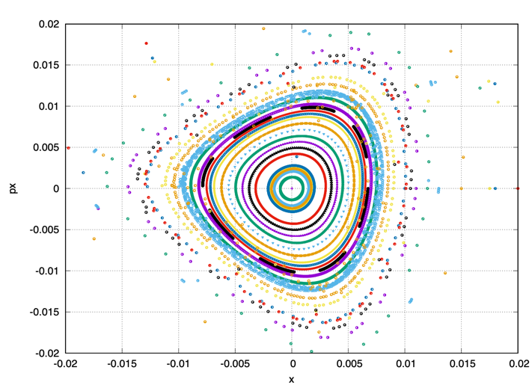
Working point for the entire ring $9,44×9,44$, the same as for the regular structure. Figure 3 shows the dynamic apertures for this working point in both planes for different $dp/p$. Dynamic aperture in x-plane: $300 mm×mrad$; в y-plane: $100 mm×mrad$;
dp/p = 0.0%
dp/p = 0.5 %
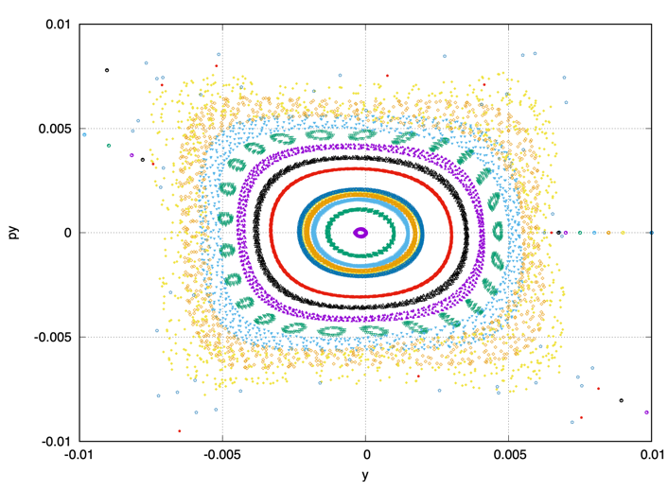
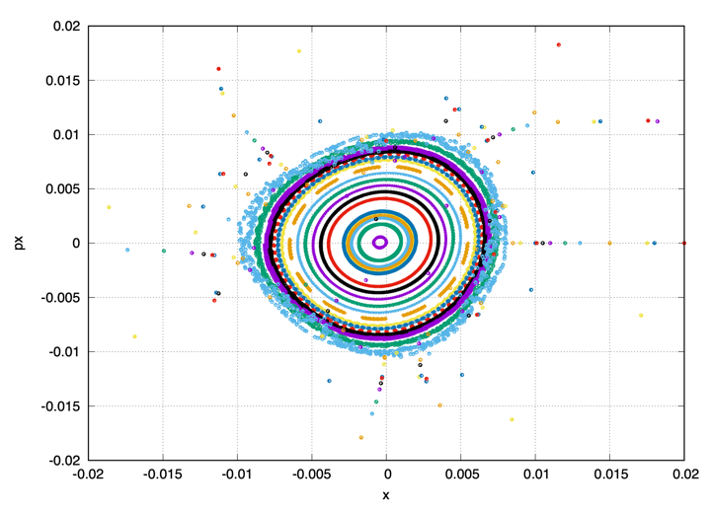
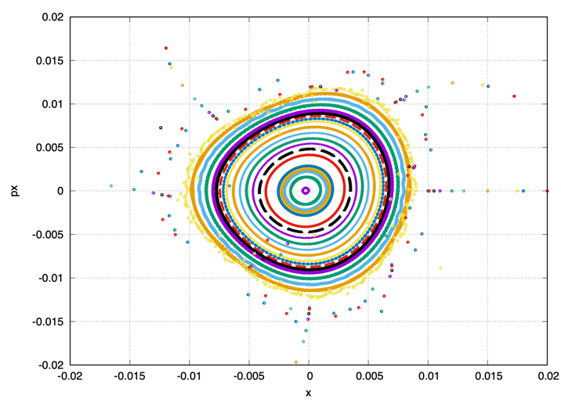
dp/p = 0.3%
Рисунок 9 Динамическая аппретура для случая плавления дисперсии крайними квадруполями.
Слева – x-плоскость; справа – y-плоскость.
  - Подавление дисперсии двумя семействами квадруполей арки.
    - Выбор градиентов квадруполей

This method shows that it is possible to suppress the dispersion in straight sections using only two families of focusing quadrupoles.
It is important to consider here, as in the first case, to perform:
- Obtaining the required critical energy value for the entire collider ring, which corresponds to $γ_{tr}\sim 15-16$;
- Only by using quadrupoles of two families to suppress the variance in straight sections.
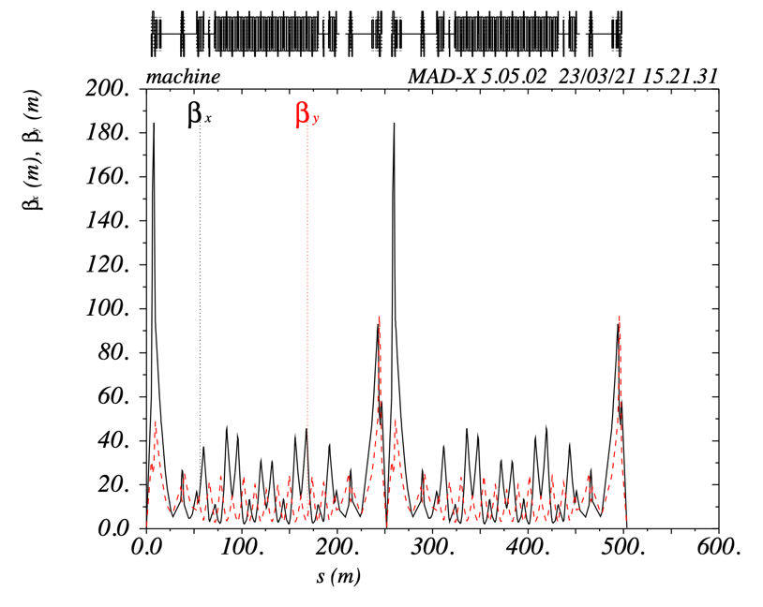
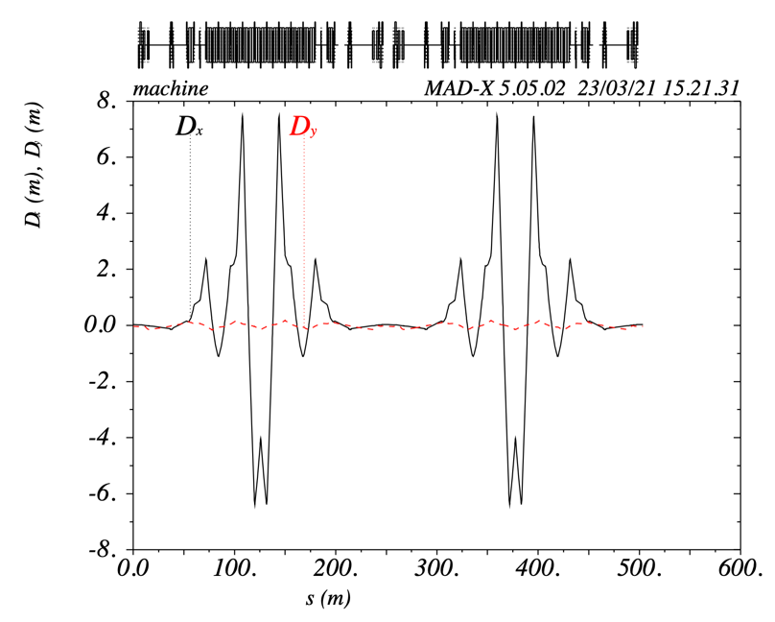
Рисунок 10 Подавление дисперсии двумя семействами квадруполей.
Слева – бета-функции; Справа – дисперсионные функции.
Initially, the superperiod is selected, as in the first case with a tune shift on the superperiod $ν_{s}=0,75$. Thus, we get the values of the quadrupoles QF1 and QF2 for the entire arc, including at the edges.
However, it turns out that the dispersion in the straight sections is not suppressed. For suppression, the values of the quadrupole gradients change, but in this case the phase shift on the arc becomes equal to $ν_{x arc}=2,72178, ν_{y arc}=2,99884$, thus in the x–plane, it is a multiple of $2π$.

Квадруполи | Градиент, T/m
QF1 | 28,95
QF2 | 19,91
QD | –22,6

In this case, to achieve the required critical energy value, it is necessary to provide a greater modulation of the quadrupole gradients than in the case of dispersion suppression by edge superperiods.

    - Расстановка секступолей
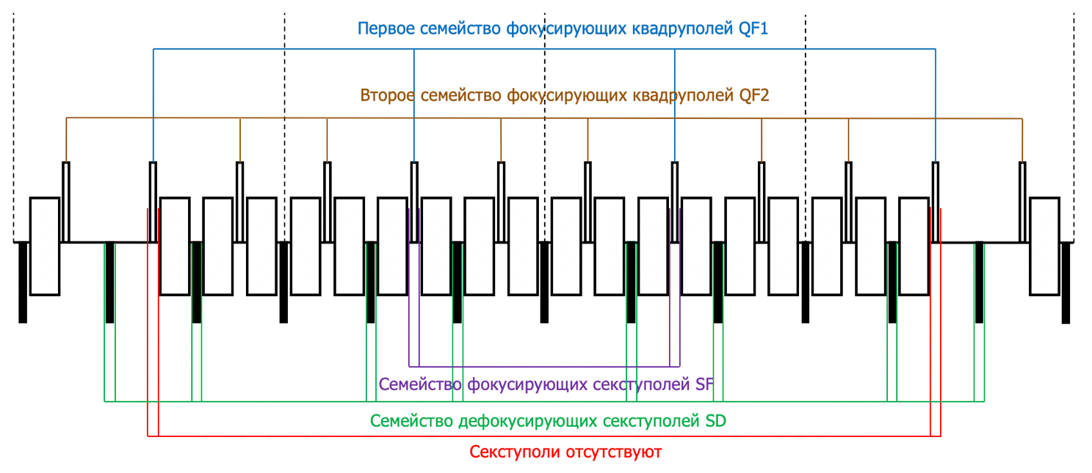
Рисунок 11 Принципиальная схема расстановке секступолей в случае подавления дисперсии двумя семействами квадруполей

В силу того, что набег на арке не кратен $2π$, а также между центральными квадруполями не кратен $π/2$, а равен $1,41$, получается что секступоли не компенсируют друг друга в точности. Расстановка секступолей для этого случая отлична от расстановки секступолей при наличии подавителей дисперсии на краях арки. Семейство SF устанавливаться рядом c центральными квадруполями суперпериода QF1, а SD рядом с дефокусирующими квадруполями QD, но только теми, которые окружают QF1 слева и справа. Однако, в крайних суперпериодах секступоли фокусирующего семейства отсутствуют. Это сделано для уменьшения влияния секступолей на динамическую апертуру. Подавление же хроматичности возможно и без них, так как основной вклад вносят секступоли 2 и 3 суперпериода.
    - Динамическая апертура и рабочая точка

Рабочая точка для всего кольца $9,44×9,44$, такая же как и для регулярной структуры. На Рисунке 3 изображены динамические аппретуры для этой рабочей точки в обоих плоскостях для разных $dp/p$. Динамическая апертура в x-плоскости: $300 мм×мрад$; в x-плоскости: $200 мм×мрад$;
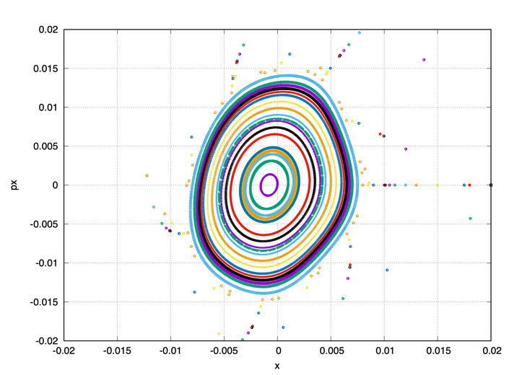
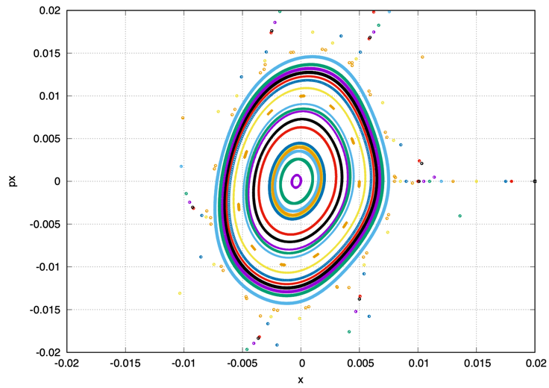
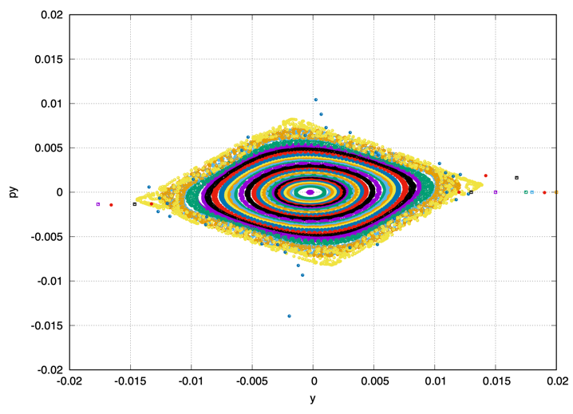
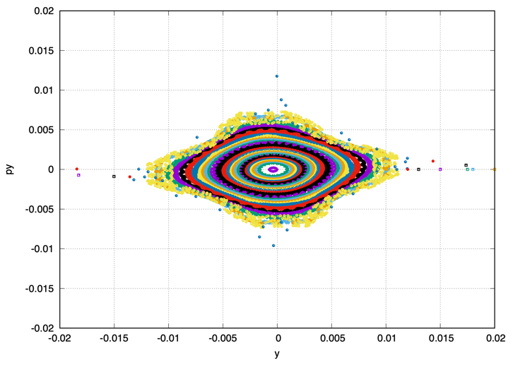
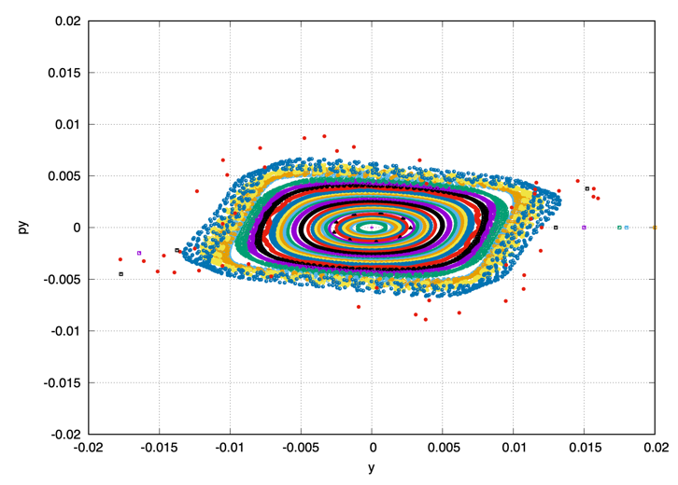
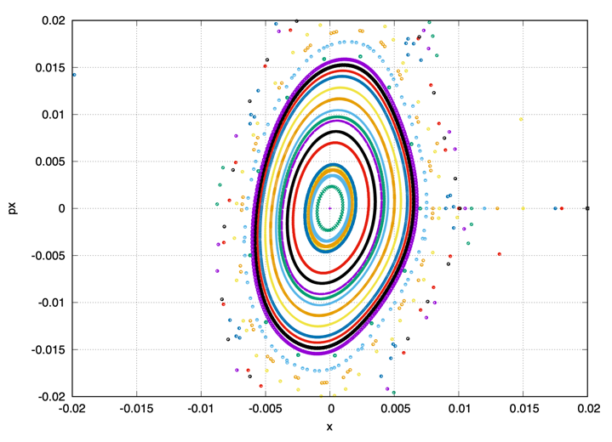
Рисунок 12 Динамическая апертура в случае подавление дисперсии двумя семействами квадруполей.
Слева – x-плоскость; справа – y-плоскость.
dp/p = 0.5 %
dp/p = 0.1 %
dp/p = 0.3 %

Литература.

- Yu. V. Senichev and A. N. Chechenin. Theory of “Resonant” Lattices for Synchrotrons with Negative Momentum Compaction Factor. Journal of Experimental and Theoretical Physics, 2007, Vol. 105, No. 5, pp. 988–997
- Yu. V. Senichev and A. N. Chechenin. Construction of “Resonant” Magneto-Optical Lattices with Controlled Momentum Compaction Factor Journal of Experimental and Theoretical Physics, 2007, Vol. 105, No. 6, pp. 1141–1156.
- Yu. Senichev, A. Chechenin, S. Kostromin. Variable Transition Energy Lattices based on different periodic cells with various types of dispersion suppressor.
- Bruno Autin Dispersion Suppression with Missing Magnets in a FODO Structure Application To The CERN Antiproton Accumulator, IEEE Transactions on Nuclear Science Vol. NS-26, No. 3, June 1979.
- Bernhard J. Holzer. Beam optics and lattice design for particle accelerators. CERN Yellow Report CERN-2013-001, pp.171-206
- B. Lorentz, A. Lehrach, R. Maier, D. Prasuhn, H. Stockhorst, and R. Tölle, Forschungszentrum Jülich GmbH, D-52425 Jülich, Germany. HESR Linear Lattice Design. Proceedings of EPAC08, Genoa, Italy.
- P.J.Bryant, Planning Sextupole Families in a Circular Collider. Advanced accelerator physics. Proceedings, 5th Course of the CERN Accelerator School, Rhodos, Greece, September 20-October 1, 1993. Vol. 1, 2.
- Е. М. Сыресин, А. В. Бутенко, П.Р. Зенкевич, О.С. Козлов, С.Д. Колокольчиков, С.А. Костромин, И.Н. Мешков, Н.В. Митянина, Ю.В. Сеничев, А.О. Сидорин, Г.В.Трубников. Формирование Поляризованных Протонных Пучков в Ускорительном Комплексе Коллайдера NICA.

